Kuubernet Dashboard [root@k-master ~]# k**ubectl apply -f https://raw.githubusercontent.com/kubernetes/dashboard/master/aio/deploy/recommended.yaml**

namespace/kubernetes-dashboard created

serviceaccount/kubernetes-dashboard created

service/kubernetes-dashboard created

secret/kubernetes-dashboard-certs created

secret/kubernetes-dashboard-csrf created

secret/kubernetes-dashboard-key-holder created

configmap/kubernetes-dashboard-settings created

role.rbac.authorization.k8s.io/kubernetes-dashboard created

clusterrole.rbac.authorization.k8s.io/kubernetes-dashboard unchanged

rolebinding.rbac.authorization.k8s.io/kubernetes-dashboard created

clusterrolebinding.rbac.authorization.k8s.io/kubernetes-dashboard unchanged

deployment.apps/kubernetes-dashboard created

service/dashboard-metrics-scraper created

deployment.apps/dashboard-metrics-scraper created

[root@k-master ~]#

[root@k-master ~]# **wget https://raw.githubusercontent.com/kubernetes/dashboard/master/aio/deploy/recommended.yaml**

--2020-06-21 07:56:45-- https://raw.githubusercontent.com/kubernetes/dashboard/master/aio/deploy/recommended.yaml

Resolving raw.githubusercontent.com (raw.githubusercontent.com)... 151.101.0.133, 151.101.64.133, 151.101.128.133, ...

Connecting to raw.githubusercontent.com (raw.githubusercontent.com)|151.101.0.133|:443... connected.

HTTP request sent, awaiting response... 200 OK

Length: 7552 (7.4K) [text/plain]

Saving to: ‘recommended.yaml.1’

100%[==============================================================================================================================>] 7,552 --.-K/s in 0s

2020-06-21 07:56:45 (60.5 MB/s) - ‘recommended.yaml.1’ saved [7552/7552]

[root@k-master ~]# **mv recommended.yaml kubernetes-dashboard-deployment.yml**

[root@k-master ~]# **vim** **kubernetes-dashboard-deployment.yml**

**Add NodePort here**

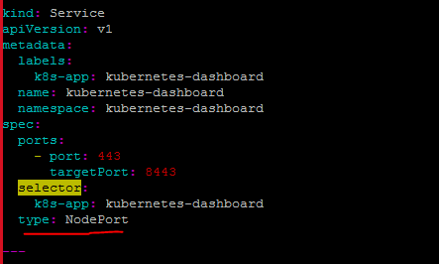

[root@k-master ~]# **kubectl apply -f kubernetes-dashboard-deployment.**yml

namespace/kubernetes-dashboard unchanged

serviceaccount/kubernetes-dashboard unchanged

service/kubernetes-dashboard configured

secret/kubernetes-dashboard-certs unchanged

secret/kubernetes-dashboard-csrf unchanged

secret/kubernetes-dashboard-key-holder unchanged

configmap/kubernetes-dashboard-settings unchanged

role.rbac.authorization.k8s.io/kubernetes-dashboard unchanged

clusterrole.rbac.authorization.k8s.io/kubernetes-dashboard unchanged

rolebinding.rbac.authorization.k8s.io/kubernetes-dashboard unchanged

clusterrolebinding.rbac.authorization.k8s.io/kubernetes-dashboard unchanged

deployment.apps/kubernetes-dashboard configured

service/dashboard-metrics-scraper unchanged

deployment.apps/dashboard-metrics-scraper unchanged

[root@k-master ~]# **kubectl get deployments -n kubernetes-dashboard**

NAME READY UP-TO-DATE AVAILABLE AGE

dashboard-metrics-scraper 1/1 1 1 2m2s

kubernetes-dashboard 0/1 1 0 2m3s

[root@k-master ~]# **kubectl get deployments -n kubernetes-dashboard**

NAME READY UP-TO-DATE AVAILABLE AGE

dashboard-metrics-scraper 1/1 1 1 2m4s

kubernetes-dashboard 0/1 1 0 2m5s

Wait for 2 min and run command again to check status

[root@k-master ~]# **kubectl get deployments -n kubernetes-dashboard**

NAME READY UP-TO-DATE AVAILABLE AGE

dashboard-metrics-scraper 1/1 1 1 2m21s

kubernetes-dashboard 1/1 1 1 2m22s

[root@k-master ~]# **kubectl get service -n kubernetes-dashboard**

NAME TYPE CLUSTER-IP EXTERNAL-IP PORT(S) AGE

dashboard-metrics-scraper ClusterIP 10.98.39.82 <none> 8000/TCP 2m51s

kubernetes-dashboard NodePort 10.110.117.75 <none> 443:31128/TCP 2m52s

[root@k-master ~]# **curl ident.me**

35.202.28.250

[root@k-master ~]# **curl https://35.202.28.250:31128**

curl: (60) Issuer certificate is invalid.

More details here: http://curl.haxx.se/docs/sslcerts.html

curl performs SSL certificate verification by default, using a "bundle"

of Certificate Authority (CA) public keys (CA certs). If the default

bundle file isn't adequate, you can specify an alternate file

using the --cacert option.

If this HTTPS server uses a certificate signed by a CA represented in

the bundle, the certificate verification probably failed due to a

problem with the certificate (it might be expired, or the name might

not match the domain name in the URL).

If you'd like to turn off curl's verification of the certificate, use

the -k (or --insecure) option.

[root@k-master ~]# curl <https://35.202.28.250:31128>

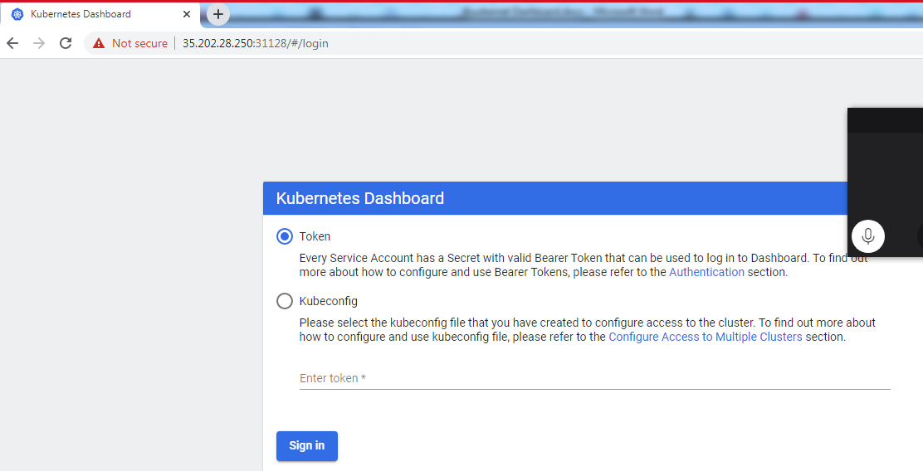

kubectl -n kubernetes-dashboard get sa

kubectl -n kubernetes-dashboard describe sa kubernetes-dashboard

kubectl -n kubernetes-dashboard describe secret kubernetes-dashboard-token-2t2hk

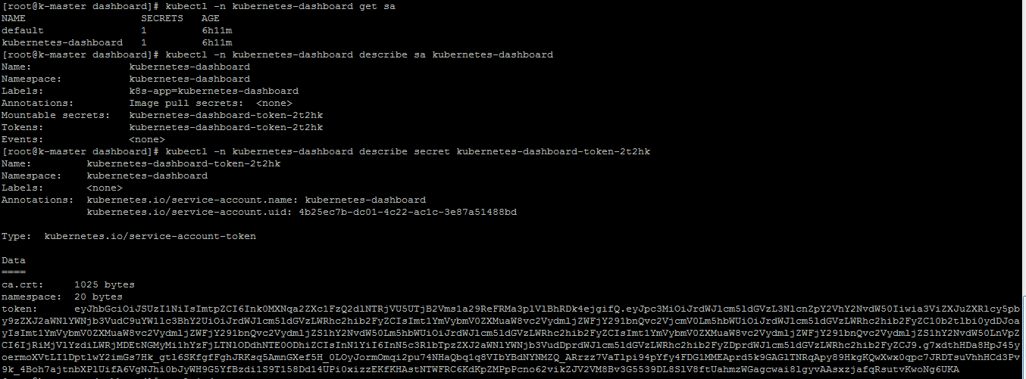

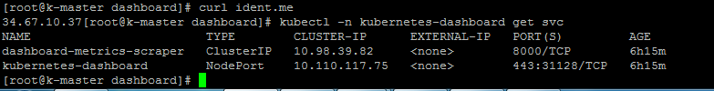

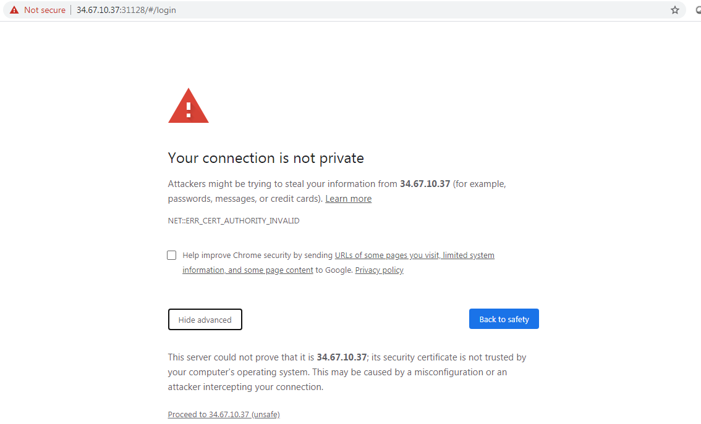

Copy the token from previous command and enter here

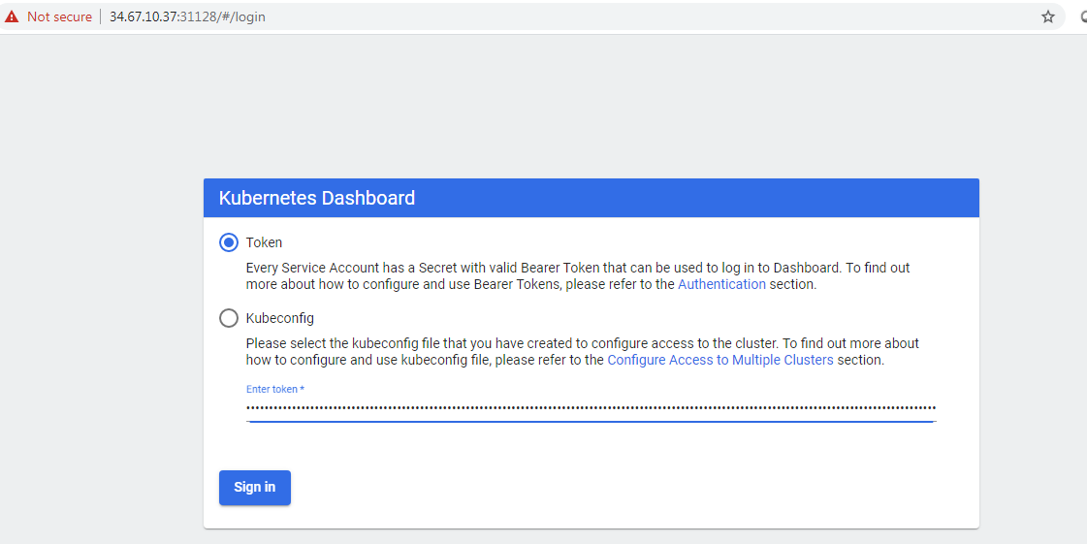

You can see everything blank here

So lets download sa admin account

git clone https://github.com/justmeandopensource/kubernetes.git

cd /root/kubernetes/dashboard

kubectl apply -f sa_cluster_admin.yaml



kubectl -n kube-system get sa

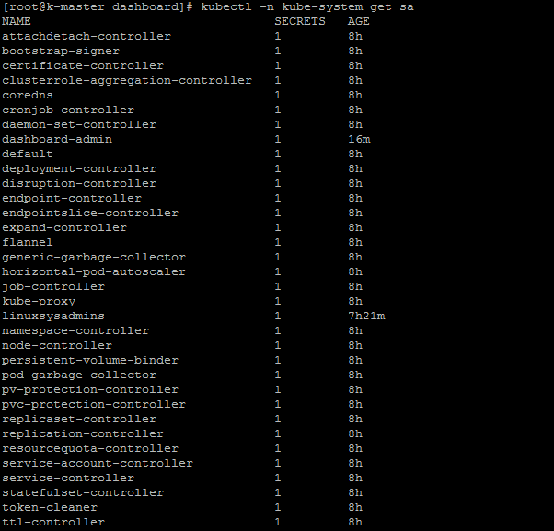

kubectl -n kube-system describe sa dashboard-admin

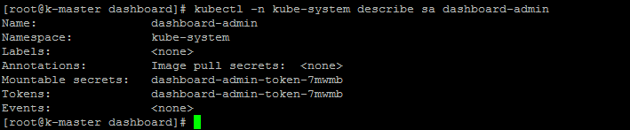

kubectl -n kube-system describe secret dashboard-admin-token-7mwmb

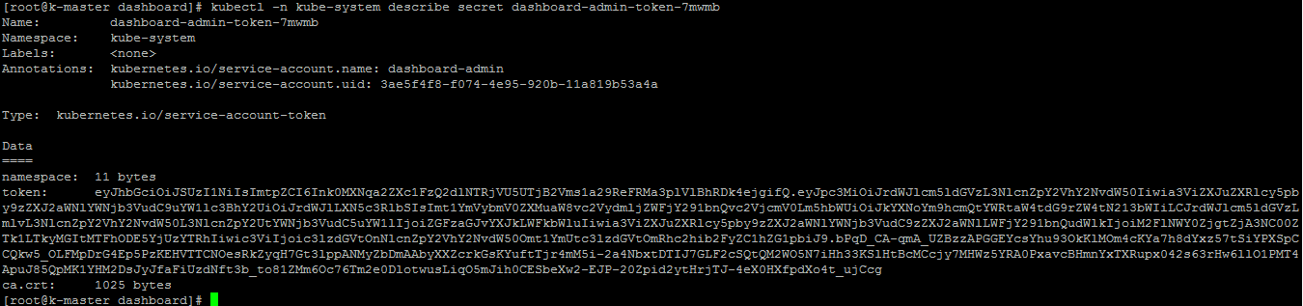

Copy token and enter here

